**Javalinez**

*Winlinez remake in Java, extended with Artificial Intelligence*

The main goals of the project are:

* creating a remake of the classical Winlinez game
* extend it with AI

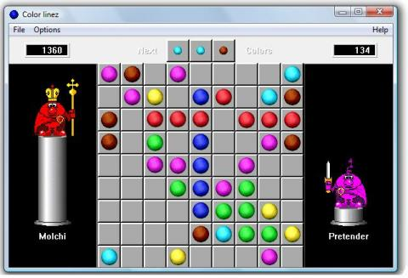Winlinez remake

The Winlinez is a single player game, where the main goal is to gain as many points as you can by removing as many coloured balls from the screen as you can.

The colours of the balls are the following:

* red
* green
* blue
* yellow
* light blue
* brown
* magenta

To remove balls, the player must place at least 5 balls from the same colour next to each other in horizontal, vertical, or diagonal line. In this case these balls will disappear.

When the player moves a ball, 3 balls will appear in random places with random colours. If the ball fills a line and at least 5 balls disappear, there no random balls appear in that turn.

The playing area is a 9x9 matrix, the game starts with 5 random balls.

Artificial Intelligence

After the remake is done, the next step is extending it with AI. I will use Neural Network and Genetic algorithm to find a good AI controller to the game.